**DEMO 1 - Navigating through the various Microsoft 365 Portals**

1. Go to office.com🡪Admin Center

The Admin Center is the central hub in managing your Microsoft365 Layers

1. The Admin Center has “cards” that you can move around depending on preference

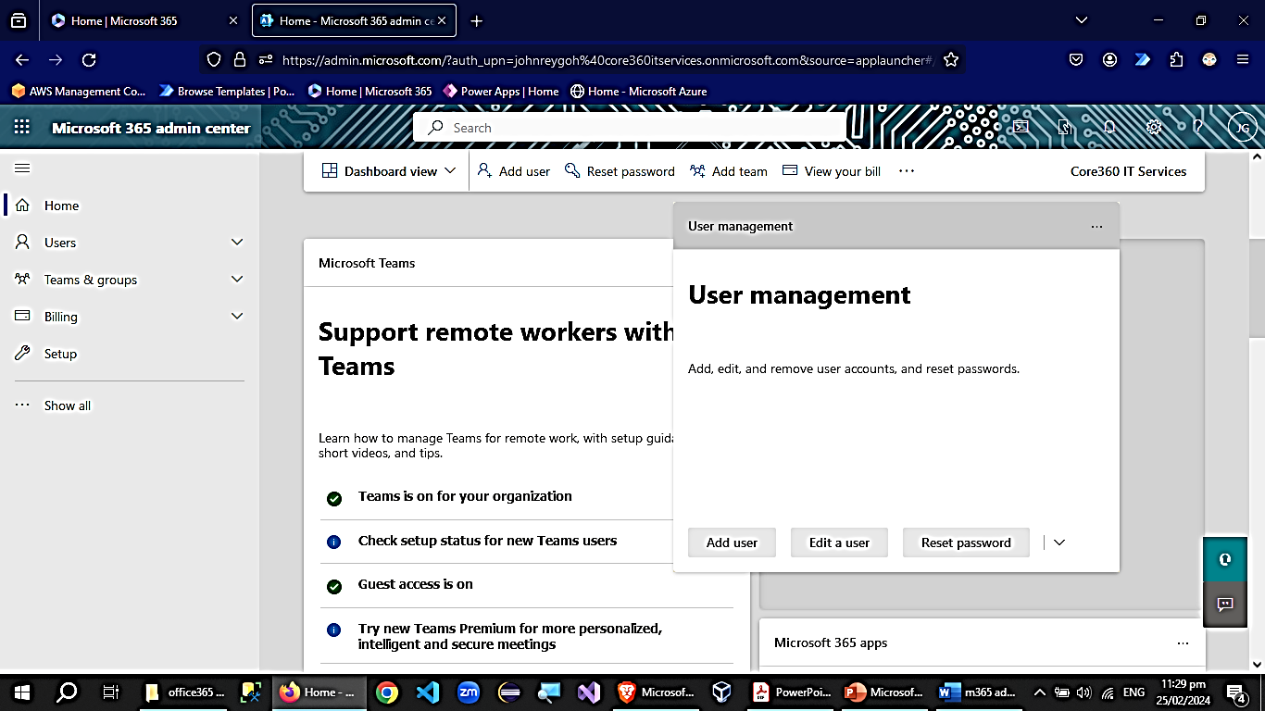

1. Toggle between Health View and Dashboard View

1. Customize the dashboard by adding cards

1. Main MS365 Admin Portal and Admin Centers

**Microsoft 365 Identity options, Plans & Azure AD Training**

**DEMO 2 - Managing Users & Licensing, Admin Roles**

**Office Apps, How your data is stored & managed & Migrating Data into 365, Groups**

**DEMO 3 - Managing Groups & Teams**